**Blood Bank Management System Project In PHP**

**Introduction**

The BLOOD BANK MANAGEMENT SYSTEM project is a great project. This project is designed for successful execution of blood bank management system functionality.

The basic building aim is to provide online blood bank service to the people. It is a browser-based system that is designed to store, process, retrieve and analyse information concerned with the administrative and inventory management within a blood bank system.

This project is built to maintaining all the information pertaining to blood donor, patient information and the stock of all the blood group available in the bank. Aim is to provide transparency in this field, make the process of obtaining blood from a blood bank hassle free and corruption free and make the system of blood bank management effective.

The Blood bank system project report contain information related to blood like –

* Blood group
* Available blood stock
* Donor detail
* Patient detail

This system is used for maintain whole information about admin, donors, blood stock and patients.

**About the project**

There are mainly 3 modules in this project.

* Admin
* Donors
* Patients

**Admin:**

Admin is the main role in the system, admin can manage all the activities like managing donor, patients and blood stock etc.

Admin can perform –

1. Check the available stock of the blood
2. Manage donors
3. Manage patients
4. Manage blood donations
5. Manage blood requests
6. Logout

Admin can manage donations like he can accept or reject the donations request based on the donor details. He can accept or reject blood requests based on the blood stock available. Admin can manage all the donor and patient. He can edit the details of donors or patients. He can delete any donor or patients.

**Donor:**

Donor is also an important role in the system. If any person or donor want to donate the blood, he or she has to register himself first. Once he or she register he/she can login to the system where he can manage or execute donor’s activities like –

1. Donate blood
2. Manage donation history
3. Check the status of donation requests
4. Logout

Once donor make a request to donate blood, admin has to take action on that request based on the donor details. Once admin accept or reject that donation request, it will be automatically update to the donor dashboard. Donor can check the status of his request. Once his donation request is accepted, he or she will be called to donate blood at the specified donation camp.

**Patient:**

Patient is the one who is suffering from any disease and he need blood. He can go to the system and register himself as a patient. Once he registers, he/she can login to the system and access patient dashboard.

Patient can perform some activities like –

1. Make blood request
2. Check the status of his request
3. Logout

Once the patient makes a request for blood, he has to provide the basic details like the no of blood units required, blood group, disease etc.

Once he makes a request, it will be reflected in the admin dashboard. Now admin has to take action on that request. Admin can accept or reject that request based on the patient details or blood stock available in the system.

**Languages used**

1. HTML
2. CSS
3. JavaScript
4. jQuery
5. PHP
6. MySQL

**Software used**

1. Text editor (any)
2. Web browser (any)
3. Xampp local serve

**Schema used**

**Admins**

|  |  |  |  |  |
| --- | --- | --- | --- | --- |
| id(int) | name(varchar) | email(varchar) | password(varchar) | mobile(bigint) |

**Donors**

|  |  |  |  |  |
| --- | --- | --- | --- | --- |
| id(int) | name(varchar) | email(varchar) | password(varchar) | mobile(bigint) |

**Patients**

|  |  |  |  |  |
| --- | --- | --- | --- | --- |
| id(int) | name(varchar) | email(varchar) | password(varchar) | mobile(bigint) |

**Donation**

|  |  |  |  |  |  |
| --- | --- | --- | --- | --- | --- |
| id(int) | donor_id(int) | blood_group(varchar) | no_units(int) | disease(varchar) | status(int) |

**Requests**

|  |  |  |  |  |  |
| --- | --- | --- | --- | --- | --- |
| id(int) | patient_id(int) | no_units(int) | blood_group(varchar) | reason(varchar) | status(int) |

**Stocks**

|  |  |  |
| --- | --- | --- |
| sno(int) | blood_group(varchar) | stock(int) |

**DFD diagram**

**Patients**

**Blood request**

**Approve/Reject donation req**

**Update status**

**Update status**

**Return status**

**Admin**

**Donors**

**Donation request**

**Login**

**Update status**

**Return status**

**Edit donor/patient**

**Update stock**

**Stock**

**ER diagram**

**Manage**

**Donation**

**Admin**

**Register**

**Manage**

**Requests**

**Register**

**Donors**

**patients**

**request**

**stocks**

**Donate**

**Screenshots**

**Home Page**

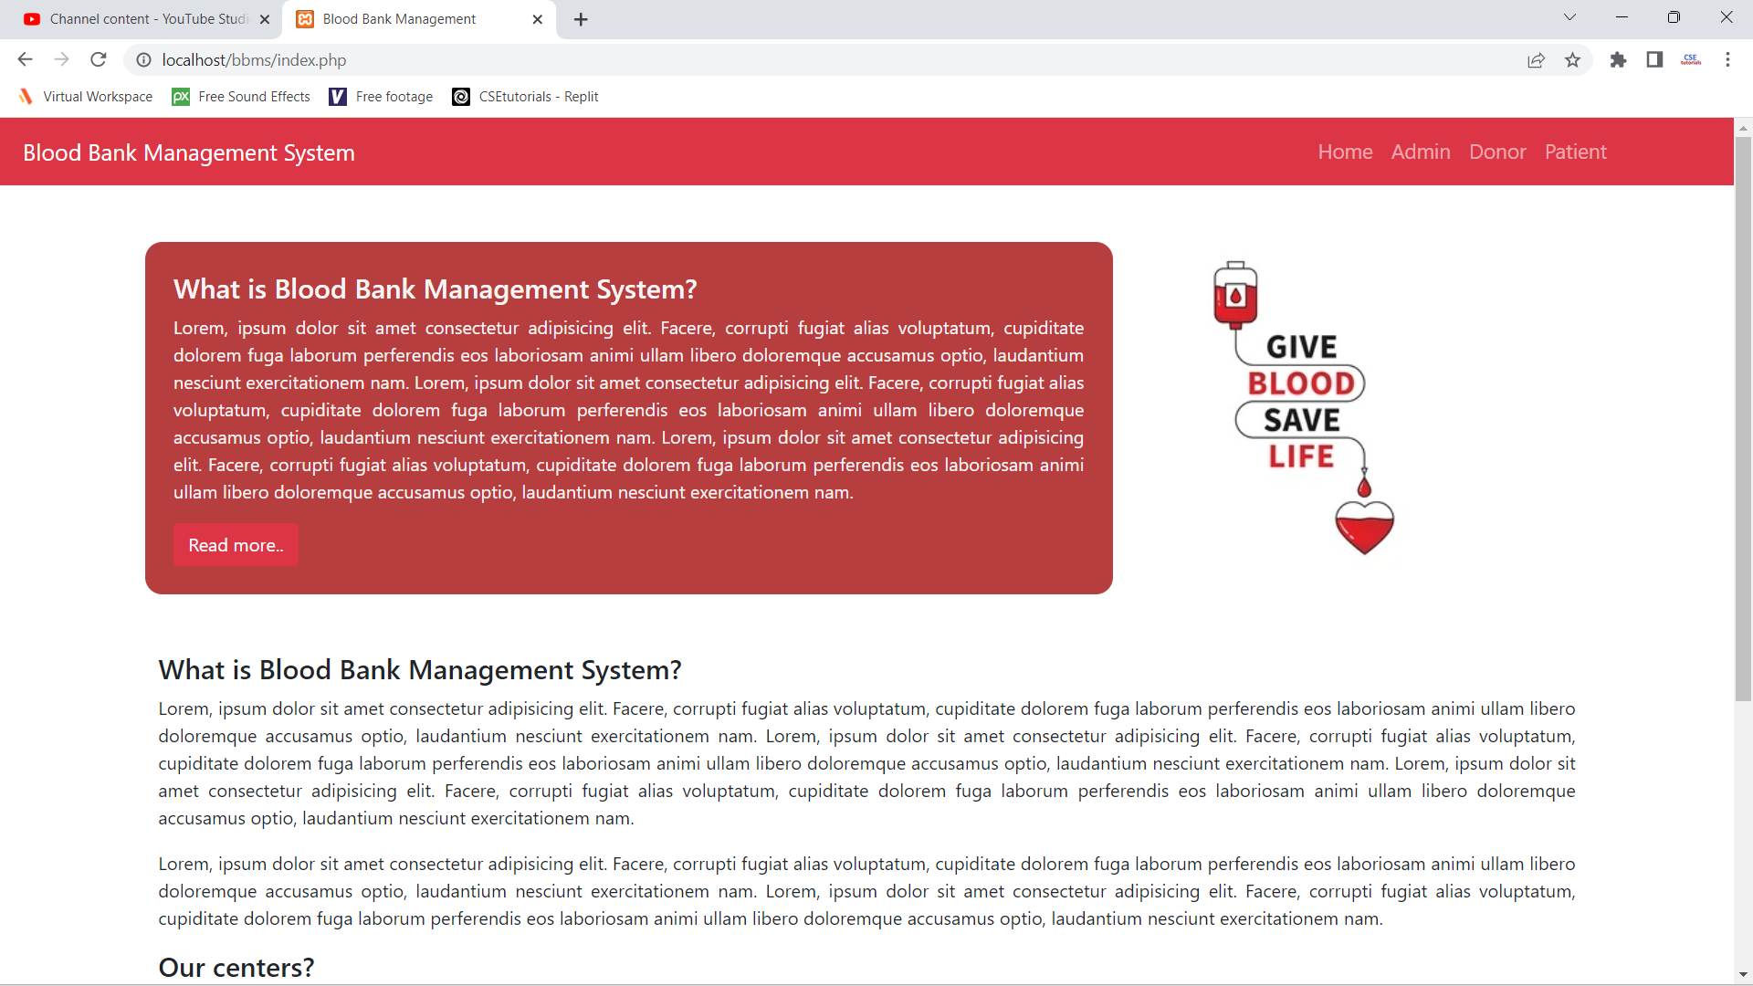

**Admin Login Page**

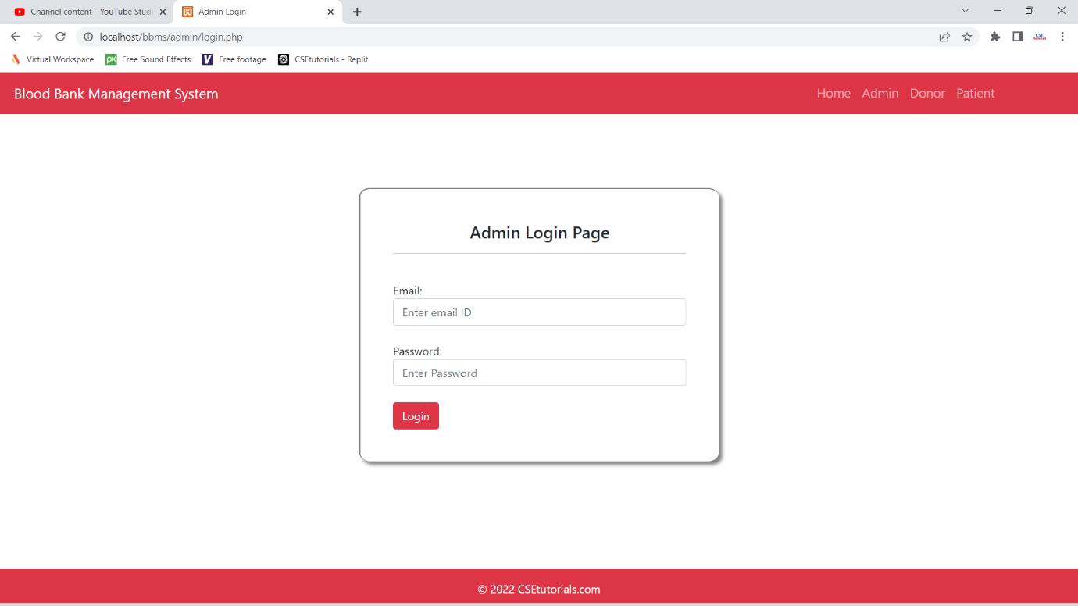

**Admin Dashboard Page**

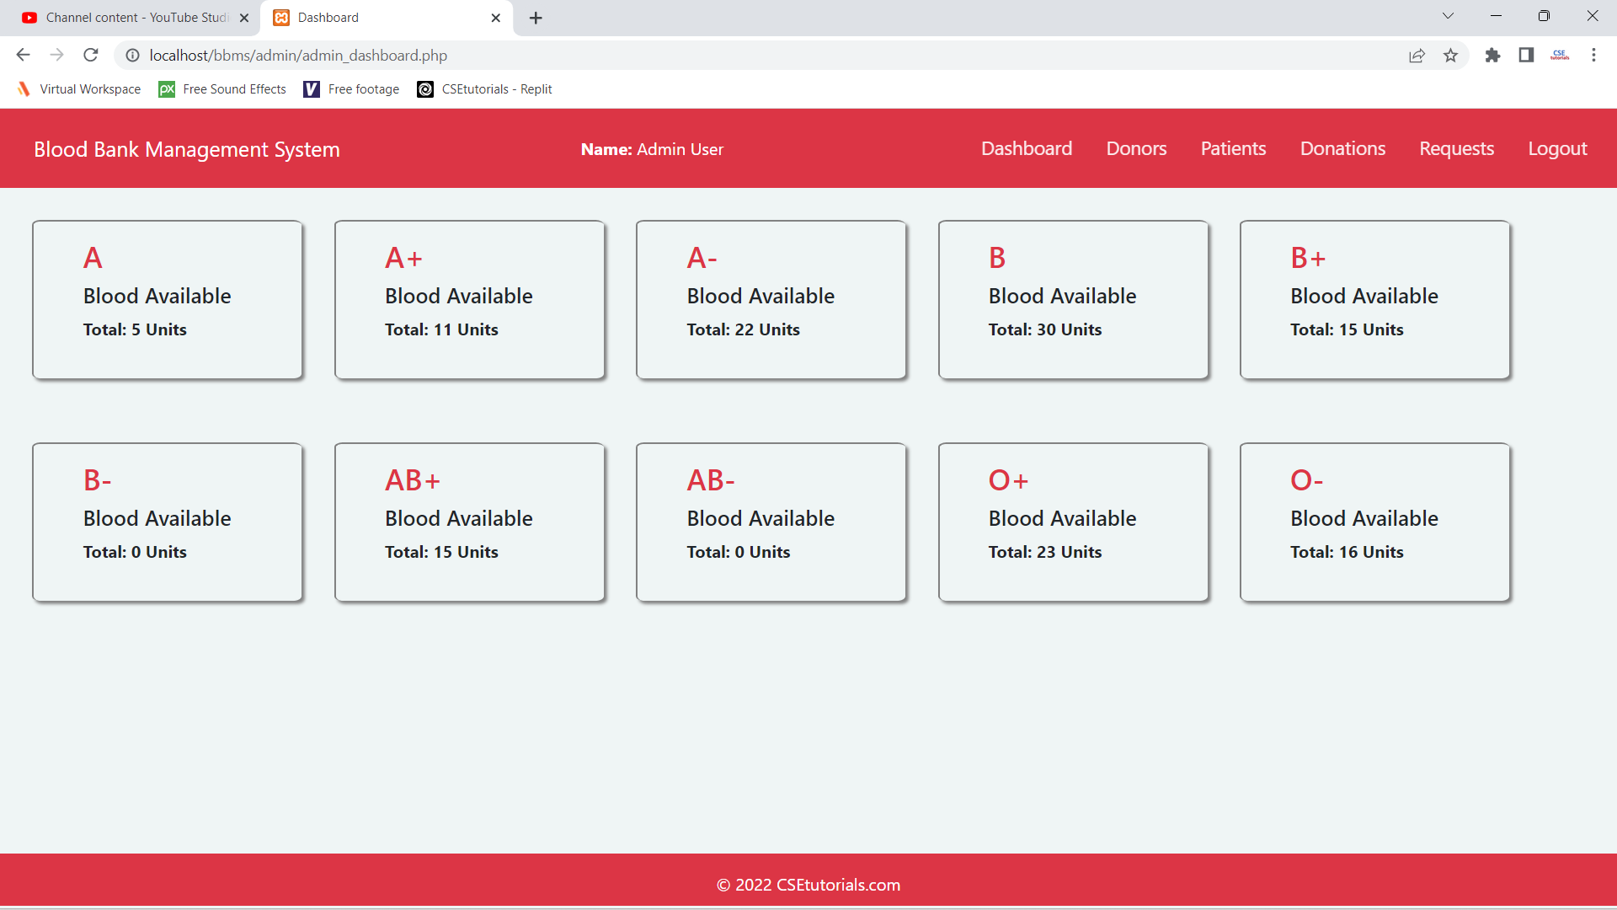

**View Donors Page**

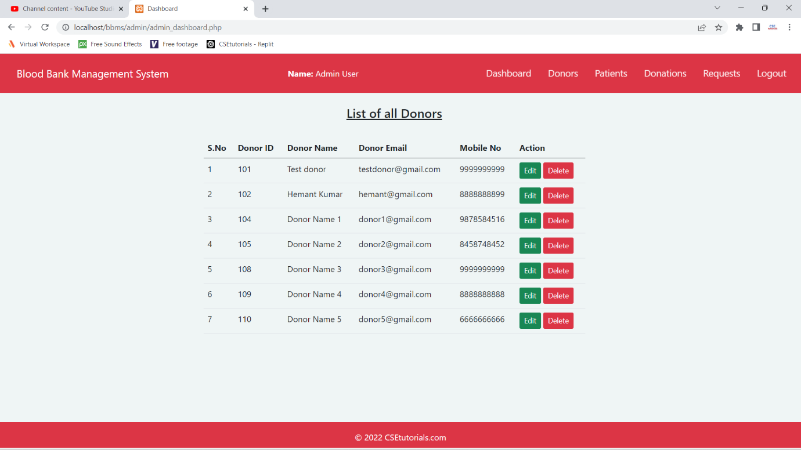

**Print Certificate**

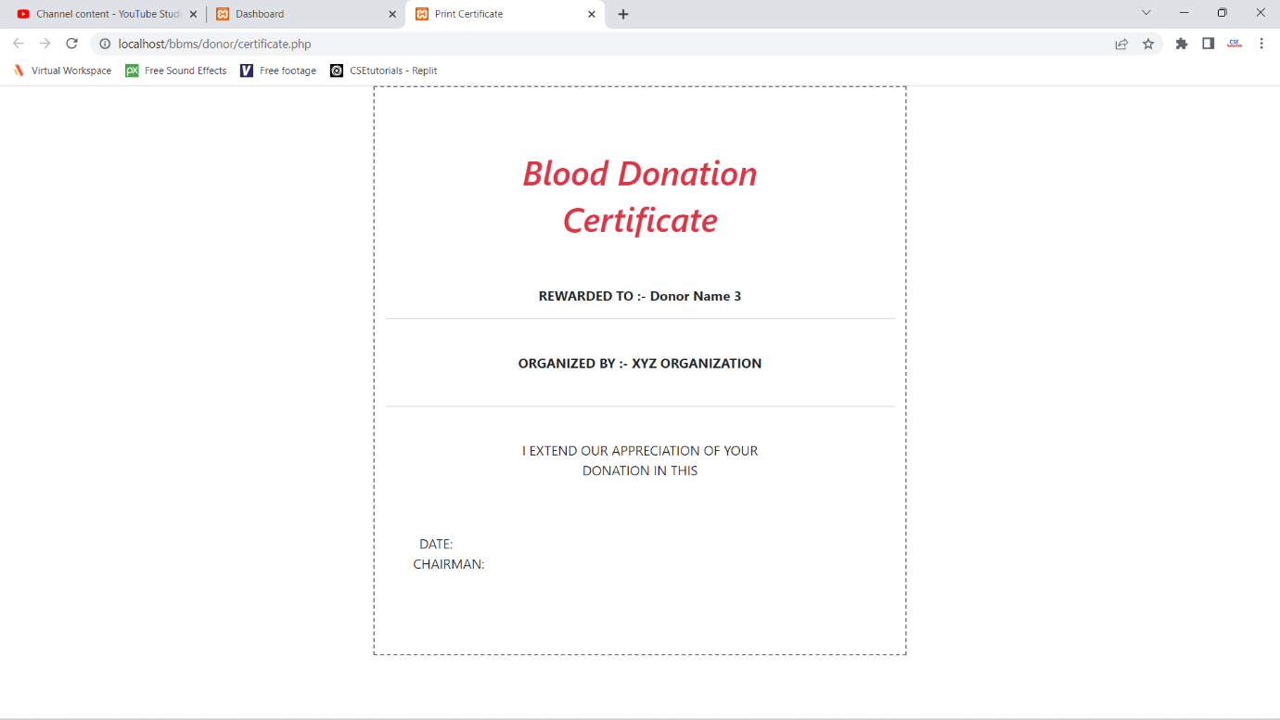

**Donor Dashboard**

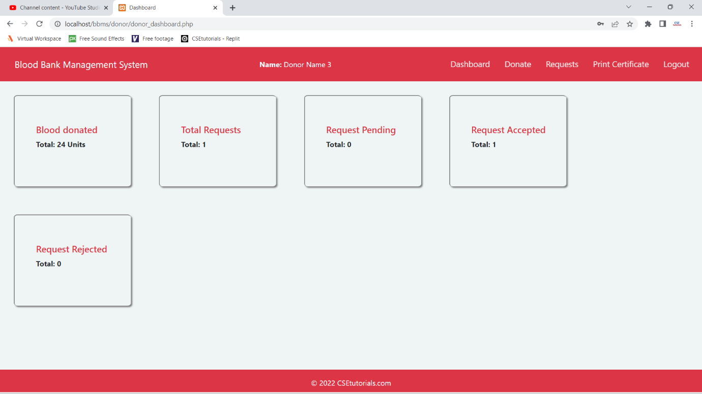

**Donate Blood Page**

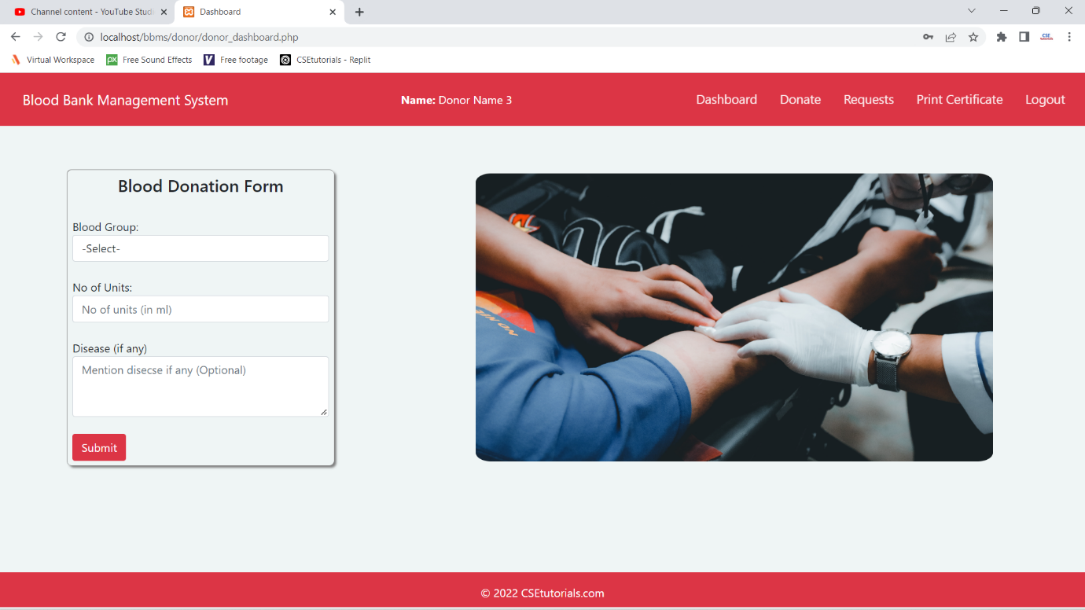

**Request Blood Page**

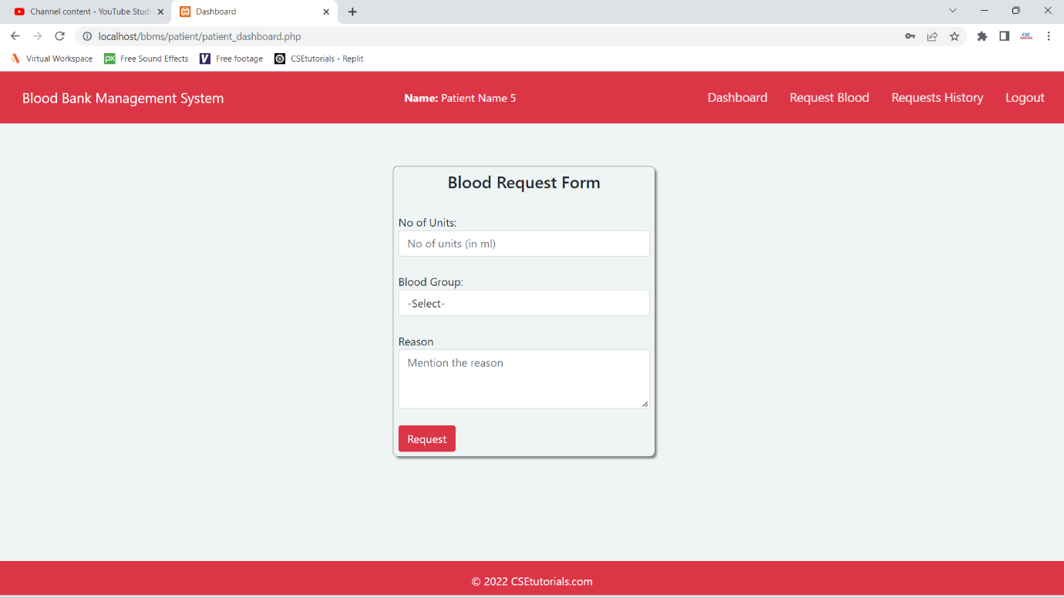

**Summary and Conclusion**

With the theoretical inclination of our syllabus, it becomes very essential to take the utmost advantage of any opportunity of gaining practical experience that comes along. The building blocks of this Major Project “Blood Bank Management System” was one of these opportunities. It gave us the requisite practical knowledge to supplement already taught theoretical concepts thus making us more competent as a computer engineer. The project from a personal point of view also helped us in understanding many aspects.

The project also provided us the opportunity of interacting with our teacher and to gain from their best experience.